(Made by Bu Guoshun A23MJ4019）

5.3 Non-functional Requirement (performance and control)

Performance :

1.Response Time: Determine response time for key operations such as searching for a book, adding a book to an exchange, or completing a transaction.

2. Throughput: Determine the maximum capacity of each transaction

3.Fault tolerance: Defines how a system behaves in the event of a failure, including recovery procedures and data integrity measures.

Control requirements:

1.Access control: Set different permissions for different types of users (e.g. administrators, moderators, ordinary users) and ensure that access to sensitive functions or data is restricted.

2. Identity authentication and authorization: Implement identity authentication, such as account password or specific Pin, to ensure that the account can access its relevant permissions.

3. Compliance: Ensure compliance with relevant regulations and standards (e.g. GDPR, PCI DSS) involving data protection, privacy and security requirements.

5.4

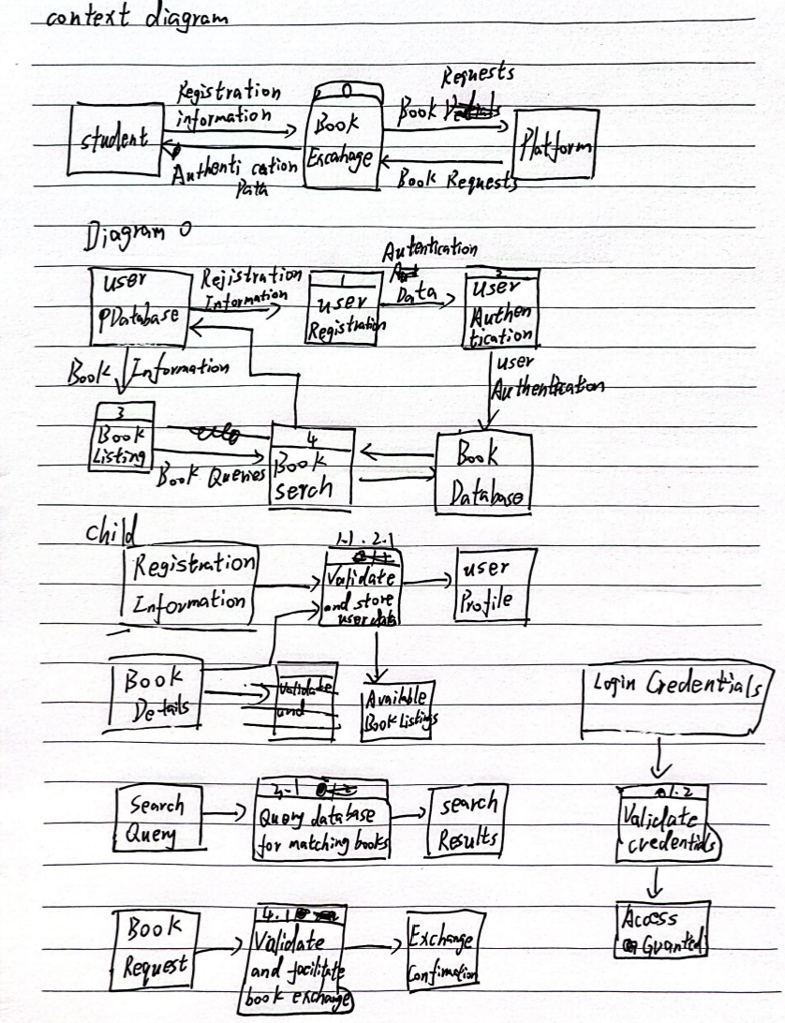

6.0

Summary of demand analysis for book exchange platform:

1. Overall goals and scope of the project: Students

Issues that the platform needs to consider:

platform security and reliability, operating costs and expected outcomes.

2. Current business process analysis (As-is analysis):

Student registration and profile creation:

Students register using an email or social media account and create a profile that includes information about their college, major, and more.

Book list management:

Students can list the books they want to exchange and provide details such as title and condition of the book.

Book searches and requests:

Students can search for available books by title or author and directly request book exchanges with other students.

3. Functional requirements:

enter:

Student input information:

- Student registration information (email, name, password, school)

- Book details (title, author, book status)

deal with:

- User authentication and authorization (verify login information)

- Book list management (store and display book details)

Output:

- Create and display student profiles

- List and display exchangeable books

- Provide search results based on query conditions

Non-functional requirements for the exchange platform:

Non-functional requirements: Performance requirements, reliability, availability, security and other quality attributes of the system. Contains performance requirements and control requirements